**1)**

$$k_{0},ρ,C=Cte\underset{→}{ }α_{0}=Cte$$

$$\left\{\left.\begin{aligned}θ=\frac{T-T_{b}}{T_{i}-T_{b}}\underset{→}{ }T=θ\left(T_{i}-T_{b}\right)+T_{b} \\ τ=\frac{α_{0}\left(1+βT_{b}\right)t}{L^{2}}\underset{→}{ }t=\frac{τL^{2}}{α_{0}\left(1+βT_{b}\right)} \\ η=\frac{x}{L}\underset{→}{ }x=ηL \end{aligned}\right\}\right.\underset{⇒}{ }\left\{\begin{aligned}\frac{1}{α_{0}}\frac{∂T}{∂t}=\frac{1}{α_{0}}\frac{∂(θ\left(T_{i}-T_{b}\right)+T_{b})}{∂({τL^{2}}/{α_{0}\left(1+βT_{b}\right)})}=\frac{α_{0}\left(1+βT_{b}\right)}{α_{0}L^{2}}\left(T_{i}-T_{b}\right)\frac{∂θ}{∂τ} \\ \left(1+βT\right)\frac{∂^{2}T}{∂x^{2}}=\left(1+βθ\left(T_{i}-T_{b}\right)+{βT}_{b}\right)\frac{T_{i}-T_{b}}{L^{2}}\frac{∂^{2}θ}{∂η^{2}} \\ β{(\frac{∂T}{∂x})}^{2}=β{(\frac{T_{i}-T_{b}}{L}\frac{∂θ}{∂η})}^{2}=β{\frac{{{(T}_{i}-T_{b})}^{2}}{L^{2}}(\frac{∂θ}{∂η})}^{2} \end{aligned}\right.$$

$$\frac{1}{α_{0}}\frac{∂T}{∂t}=\left(1+βT\right)\frac{∂^{2}T}{∂x^{2}}+β{(\frac{∂T}{∂x})}^{2}\underset{⇒}{ }\frac{∂θ}{∂τ}=\frac{1}{\left(T_{i}-T_{b}\right)}\frac{L^{2}}{\left(1+βT_{b}\right)}\left[\left(1+βθ\left(T_{i}-T_{b}\right)+{βT}_{b}\right)\frac{T_{i}-T_{b}}{L^{2}}\frac{∂^{2}θ}{∂η^{2}}+β{\frac{{{(T}_{i}-T_{b})}^{2}}{L^{2}}(\frac{∂θ}{∂η})}^{2}\right]$$

$$\underset{⇒}{ }\frac{∂θ}{∂τ}=\underset{1+Pθ}{\underbrace{\frac{1+βθ\left(T_{i}-T_{b}\right)+{βT}_{b}}{1+βT_{b}}}}\frac{∂^{2}θ}{∂η^{2}}+\underset{P}{\underbrace{\frac{β{(T}_{i}-T_{b})}{1+βT_{b}}}}{\left(\frac{∂θ}{∂η}\right)}^{2}$$

$$\underset{⇒}{ }\frac{∂θ}{∂τ}=(1+Pθ)\frac{∂^{2}θ}{∂η^{2}}+P{(\frac{∂θ}{∂η})}^{2}$$

**2)**

$$\frac{∂θ}{∂τ}=\left(1+Pθ\right)\frac{∂^{2}θ}{∂η^{2}}+P{\left(\frac{∂θ}{∂η}\right)}^{2}\left\{\left.\begin{aligned}\frac{∂θ}{∂τ}=\frac{θ_{η}^{τ+∆τ}-θ_{η}^{τ}}{∆τ} \\ \frac{∂θ}{∂η}=\frac{θ_{η+1}^{τ}-θ_{η-1}^{τ}}{2∆η} \\ \frac{∂^{2}θ}{∂η^{2}}=\frac{θ_{η+1}^{τ}+θ_{η-1}^{τ}-{2θ}_{η}^{τ}}{∆η^{2}}\end{aligned}\right\}\right.\underset{⇒}{ }\frac{θ_{η}^{τ+∆τ}-θ_{η}^{τ}}{∆τ}=\left(1+Pθ_{η}^{τ}\right)\frac{θ_{η+1}^{τ}+θ_{η-1}^{τ}-{2θ}_{η}^{τ}}{∆η^{2}}+P{(\frac{θ_{η+1}^{τ}-θ_{η-1}^{τ}}{2∆η})}^{2}$$

$$\underset{⇒}{ }θ_{η}^{τ+∆τ}=θ_{η}^{τ}+\underset{M}{\underbrace{\frac{∆τ}{∆η^{2}}}}[\left(1+Pθ_{η}^{τ}\right){(θ}_{η+1}^{τ}+θ_{η-1}^{τ}-{2θ}_{η}^{τ})+\frac{1}{4}P({θ_{η+1}^{τ}}^{2}+{θ_{η-1}^{τ}}^{2}-2θ_{η+1}^{τ}θ_{η-1}^{τ})]$$

$$\underset{⇒}{ }θ_{η}^{τ+∆τ}=θ_{η}^{τ}+M{(θ}_{η+1}^{τ}+θ_{η-1}^{τ}-{2θ}_{η}^{τ})+PMθ_{η}^{τ}{(θ}_{η+1}^{τ}+θ_{η-1}^{τ}-{2θ}_{η}^{τ})+\frac{1}{4}PM({θ_{η+1}^{τ}}^{2}+{θ_{η-1}^{τ}}^{2}-2θ_{η+1}^{τ}θ_{η-1}^{τ})$$

$$\underset{⇒}{ }θ_{η}^{τ+∆τ}=θ_{η}^{τ}(1-2M)+M{(θ}_{η+1}^{τ}+θ_{η-1}^{τ})+PMθ_{η}^{τ}{(θ}_{η+1}^{τ}+θ_{η-1}^{τ}-{2θ}_{η}^{τ})+\frac{1}{4}PM({θ_{η+1}^{τ}}^{2}+{θ_{η-1}^{τ}}^{2}-2θ_{η+1}^{τ}θ_{η-1}^{τ})$$

**3)**

$$\left.\begin{matrix}∆τ≤\frac{{(∆η)}^{2}}{2(1+P)} \\ \\ Max\left(P\right)=5 \end{matrix}\right\}\underset{→}{ }∆τ≤0.000208\overline{3}\underset{→}{ }∆τ=0.0001$$

**4)**

$$\left.\begin{matrix}Q^{''}=ρc\int_{0}^{L}{\left(T(x)-T_{b}\right)dx} \\ \\ Q_{0}^{''}=ρcL\left(T_{i}-T_{b}\right) \end{matrix}\right\}\underset{⇒}{ }{Q^{''}}/{Q_{0}^{''}}=\frac{\int_{0}^{L}{Tdx}-{LT}_{b}}{{LT}_{i}-{LT}_{b}}\underset{⇒}{ T=θ\left(T_{i}-T_{b}\right)+T_{b} }{Q^{''}}/{Q_{0}^{''}}=\frac{\left[\int_{0}^{L}{\left(θ\left(T_{i}-T_{b}\right)+T_{b}\right)dx}\right] - \left[Lθ_{b}\left(T_{i}-T_{b}\right)+LT_{b}\right]}{\left[Lθ_{i}\left(T_{i}-T_{b}\right)+LT_{b}\right] - \left[Lθ_{b}\left(T_{i}-T_{b}\right)+LT_{b}\right]}$$

$$\underset{⇒}{ }{Q^{''}}/{Q_{0}^{''}}=\frac{\left(T_{i}-T_{b}\right)\int_{0}^{L}{θdx}+\int_{0}^{L}{T_{b}dx} - Lθ_{b}\left(T_{i}-T_{b}\right)-{LT}_{b}}{L\left(T_{i}-T_{b}\right)(θ_{i}-θ_{b})}\underset{⇒}{ dx=d\left(ηL\right)=Ldη }{Q^{''}}/{Q_{0}^{''}}=\frac{L\left(T_{i}-T_{b}\right)\int_{0}^{1}{θdη}+LT_{b} - Lθ_{b}\left(T_{i}-T_{b}\right)-LT_{b}}{L\left(T_{i}-T_{b}\right)(θ_{i}-θ_{b})}$$

$$\underset{⇒}{ }{Q^{''}}/{Q_{0}^{''}}=\frac{L\left(T_{i}-T_{b}\right)\int_{0}^{1}{θdη} - Lθ_{b}\left(T_{i}-T_{b}\right)}{L\left(T_{i}-T_{b}\right)\left(θ_{i}-θ_{b}\right)}=\frac{L\int_{0}^{1}{θdη} - Lθ_{b}}{L\left(θ_{i}-θ_{b}\right)}=\frac{\int_{0}^{1}{θdη} - θ_{b}}{θ_{i}-θ_{b}}\left\{\left.\begin{aligned}θ_{b}=\frac{T_{b}-T_{b}}{T_{i}-T_{b}}=0 \\ \\ θ_{i}=\frac{T_{i}-T_{b}}{T_{i}-T_{b}}=1 \end{aligned}\right\}\right.\underset{⇒}{ }{Q^{''}}/{Q_{0}^{''}}=\frac{\int_{0}^{1}{θdη}-0}{1-0}$$

$$\underset{⇒}{ }{Q^{''}}/{Q_{0}^{''}}=\int_{0}^{1}{ θ dη}\underset{⇒}{ discretization }{Q^{''}}/{Q_{0}^{''}}=\sum_{i=0}^{20}{θ\left(η\right)∆η}$$

**5)**

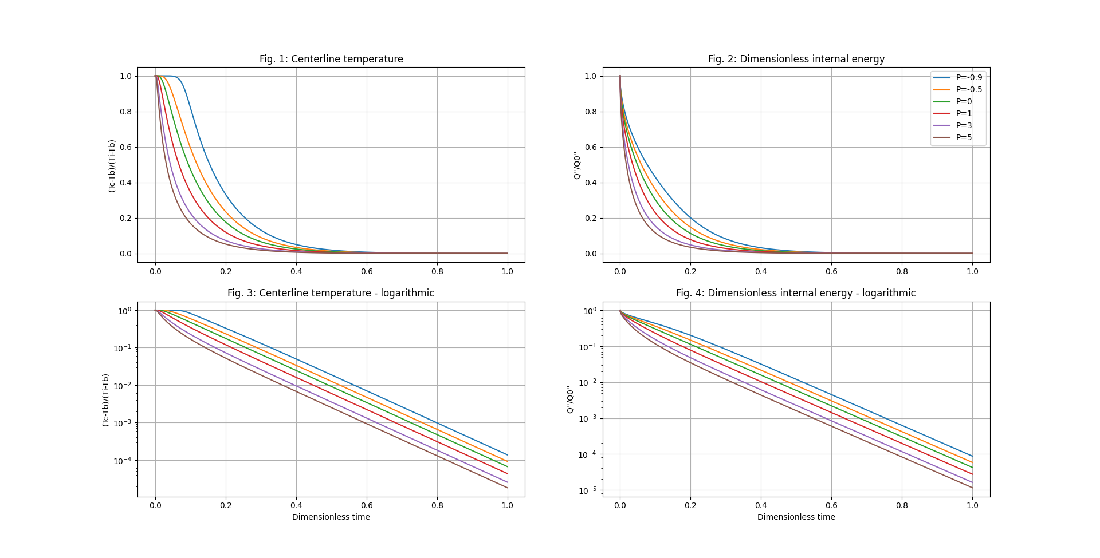

As is indicated in figures 1 and 3, in the first few moments after the temperature change, the centerline temperature for all values of $P$ follows a similar pattern of $y=0$. This is because it takes a few moments for the effects of the temperature change in the edges of the wall to reach the centerline. This delay is has a strong correlation with the value of P for our medium, as higher values of P increase the duration of this thermal lag.

Another curious property that these charts exhibit is the linear behavior with time ($τ$) that centerline temperature ($θ_{η=0.5}^{τ}$) and internal energy (${Q^{''}}/{Q_{0}^{''}}$) seem to display when viewed on a logarithmic scale. This would imply that $θ_{0.5}^{τ}$ could be written in the form ${ θ}_{0.5}^{τ}={10}^{aτ+b }$ (In Fig. 3: $\left.\begin{matrix}θ_{0.5}^{τ}={10}^{C} \\ C=aτ+b\end{matrix}\right\}\underset{→}{ }θ_{0.5}^{τ}={10}^{aτ+b}$). Verifying the correctness of this statement however, or obtaining the values for $a(P)$ or $b(P)$ would be impossible given that any closed-form expression for $θ_{0.5}^{τ}$ would have to include all previous values of $θ$ for nearly every point in the wall.

However, discovering values of $a$ and $b$ and subsequently attaining a method for immediate evaluation of centerline temperatures (or internal energy) at any desired time is entirely possible by empirically finding the slope intercept of charts obtained using numerical methods, such as figures 2 and 4. For example, simple observation of the slope will determine that for all values of $P$, $a=-4.269466$, so our function can be simplified to ${ θ}_{0.5}^{τ}={10}^{-4.269466τ+b}$. Similarly, any increase in the value of $P$ is accompanied with a decrease in values of $b$. Keep in mind that this linear approximation is only valid for $τ$ values above a certain $τ_{critical}$ threshold, which in itself seems to be a value variable with $P$ with a minimum around $P=1$.

This approximation would enable a rapid comparison of the temperature histories for various materials and a variety of temperature differences. This may be of particular use to design engineers concerned with material selection for devices which experience extreme temperature changes. Additionally, the charts themselves can be used to do this as well.

**APPENDIX A**

The computer code (written in the programming language Python) used to generate the charts presented in this project, in its entirety:

import matplotlib  
from matplotlib import pyplot as plt  
import numpy as np  
  
# M = delta_tau / (delta_eta ** 2)  
# M = 0.0001 / (0.05 ** 2)  
M = 0.04  
eta = np.arange(0, 1.05, 0.05, dtype=float) # discretizing the space array from 0 to 1  
tau = np.arange(0, 1.0001, 0.0001, dtype=float) # discretizing the time array from 0 to 1  
theta = np.zeros((10001, 21, 6))  
one = []  
two = []  
three = []  
four = []  
five = []  
six = []  
Qone = np.zeros(10001)  
Qtwo = np.zeros(10001)  
Qthree = np.zeros(10001)  
Qfour = np.zeros(10001)  
Qfive = np.zeros(10001)  
Qsix = np.zeros(10001)  
  
# Initial conditions  
for q in range(0, 5+1):  
 for b in range(0, 20+1):  
 theta[0, b, q] = 1  
for v in range(0, 5+1):  
 for w in range(1, 10000+1):  
 theta[w, 0, v] = 0  
 theta[w, 20, v] = 0

P = [-0.9, -0.5, 0, 1, 3, 5]

for j in range(0, 9999+1): # for different times  
 for k in range(1, 19+1): # for different points  
 for i in range(0, 5+1): # for different P values  
 theta[j + 1, k, i]=(theta[j, k, i] * (1 - 2 * M)) + (M * (theta[j, k + 1, i] + theta[j, k - 1, i])) + (P[i] * M * theta[j, k, i] * (theta[j, k + 1, i] + theta[j, k - 1, i] - (2 * theta[j, k, i]))) + (0.25 * P[i] * M * ((theta[j, k + 1, i] ** 2) + (theta[j, k - 1, i] ** 2) - (2 * theta[j, k + 1, i] * theta[j, k - 1, i])))  
# formulas for points k=eta=0 and k=20 or eta=1 are not needed since their temperatures are always constant

for v in range(0, 10000+1):  
 one.append(theta[v, 10, 0])  
 two.append(theta[v, 10, 1])  
 three.append(theta[v, 10, 2])  
 four.append(theta[v, 10, 3])  
 five.append(theta[v, 10, 4])  
 six.append(theta[v, 10, 5])  
 for w in range(1, 19 + 1):  
 Qone[v] += (theta[v, w, 0]) * 0.05  
 Qtwo[v] += (theta[v, w, 1]) * 0.05  
 Qthree[v] += (theta[v, w, 2]) * 0.05  
 Qfour[v] += (theta[v, w, 3]) * 0.05  
 Qfive[v] += (theta[v, w, 4]) * 0.05  
 Qsix[v] += (theta[v, w, 5]) * 0.05  
 Qone[v] += ((theta[v, 0, 0]) + (theta[v, 20, 0])) * 0.025  
 Qtwo[v] += ((theta[v, 0, 1]) + (theta[v, 20, 1])) * 0.025  
 Qthree[v] += ((theta[v, 0, 2]) + (theta[v, 20, 2])) * 0.025  
 Qfour[v] += ((theta[v, 0, 3]) + (theta[v, 20, 3])) * 0.025  
 Qfive[v] += ((theta[v, 0, 4]) + (theta[v, 20, 4])) * 0.025  
 Qsix[v] += ((theta[v, 0, 5]) + (theta[v, 20, 5])) * 0.025  
  
fig = plt.figure(figsize=(16, 9))  
plt.subplot(221)  
plt.plot(tau, one)  
plt.plot(tau, two)  
plt.plot(tau, three)  
plt.plot(tau, four)  
plt.plot(tau, five)  
plt.plot(tau, six)  
plt.title('Fig. 1: Centerline temperature')  
matplotlib.pyplot.ylabel('(Tc-Tb)/(Ti-Tb)')  
plt.grid(True)  
plt.subplot(222)  
plt.plot(tau, Qone, label='P=-0.9')  
plt.plot(tau, Qtwo, label='P=-0.5')  
plt.plot(tau, Qthree, label='P=0')  
plt.plot(tau, Qfour, label='P=1')  
plt.plot(tau, Qfive, label='P=3')  
plt.plot(tau, Qsix, label='P=5')  
plt.title('Fig. 2: Dimensionless internal energy')  
matplotlib.pyplot.ylabel('Q\'\'/Q0\'\'')  
plt.legend()  
plt.grid(True)

plt.subplot(223)  
plt.plot(tau, one)  
plt.plot(tau, two)  
plt.plot(tau, three)  
plt.plot(tau, four)  
plt.plot(tau, five)  
plt.plot(tau, six)  
plt.yscale('log')  
plt.title('Fig. 3: Centerline temperature - logarithmic')  
matplotlib.pyplot.xlabel('Dimensionless time')  
matplotlib.pyplot.ylabel('(Tc-Tb)/(Ti-Tb)')  
plt.grid(True)  
plt.subplot(224)  
plt.plot(tau, Qone)  
plt.plot(tau, Qtwo)  
plt.plot(tau, Qthree)  
plt.plot(tau, Qfour)  
plt.plot(tau, Qfive)  
plt.plot(tau, Qsix)  
plt.yscale('log')  
plt.title('Fig. 4: Dimensionless internal energy - logarithmic')  
matplotlib.pyplot.xlabel('Dimensionless time')  
matplotlib.pyplot.ylabel('Q\'\'/Q0\'\'')  
plt.grid(True)  
plt.show()

**APPENDIX B**

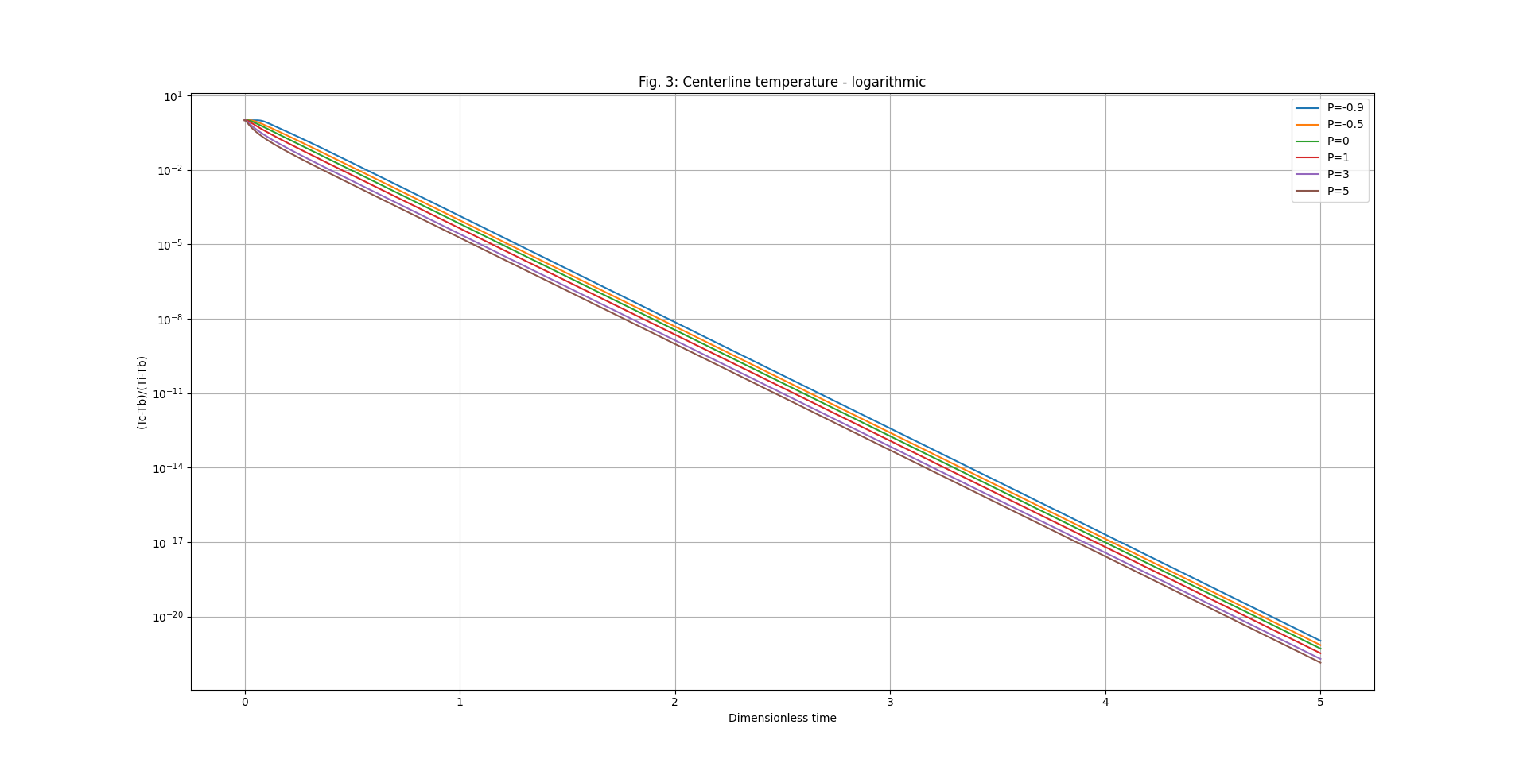

Chart further demonstrating the linear behavior that centerline temperature displays with time